**Flow chart:**

1.Duplicate reference.xml

2.End Balance validation.xml

Output file

XL Read

Program

Output file

Logging

Logging

XML Read

**Components explanation:**

1. **Excel_Read.cs:**

Connection to **Excel** sheet is facilitated through this class.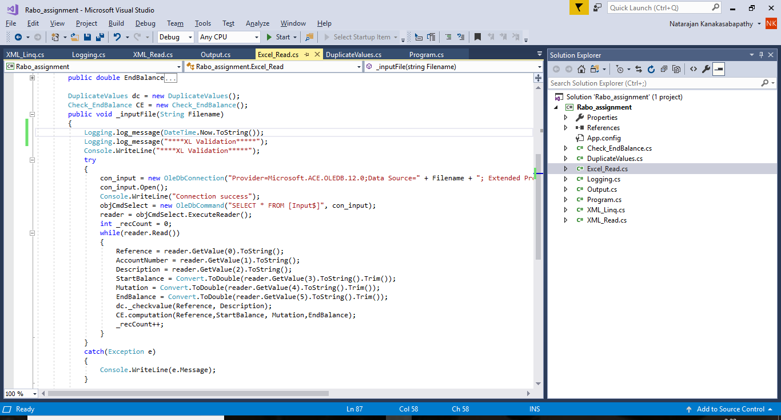

1. **XML_Linq.cs:**

Connection to **XML** is facilitated through this class.

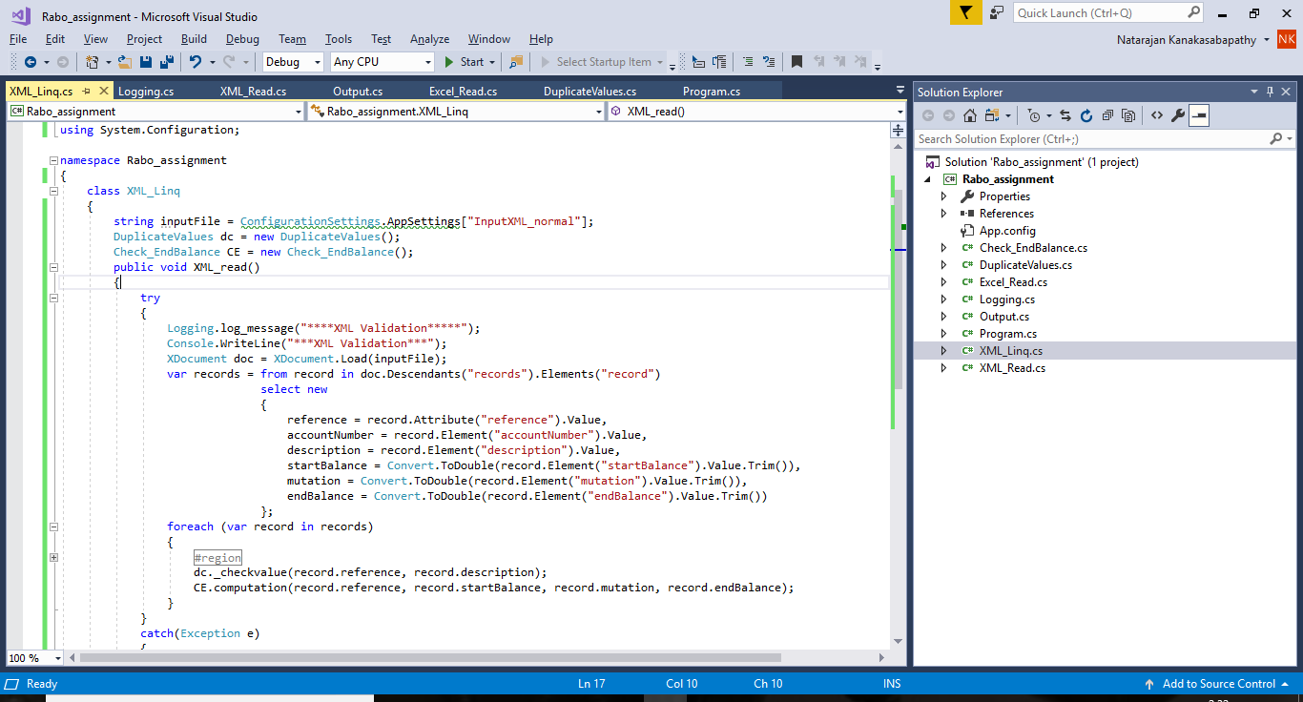

1. **Check_EndBalance.cs**

Validation of **End Balance** field is performed through this class on both excel and XML.

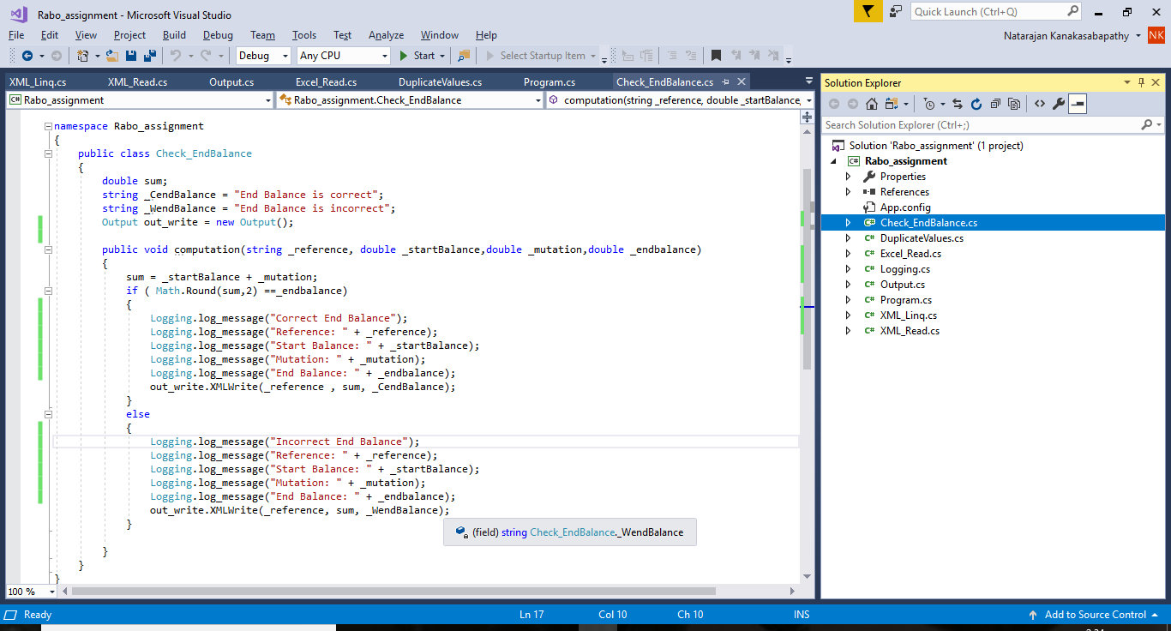

1. **DuplicateValues.cs**

This is class is used to identify the duplicate reference values in XML and Excel.

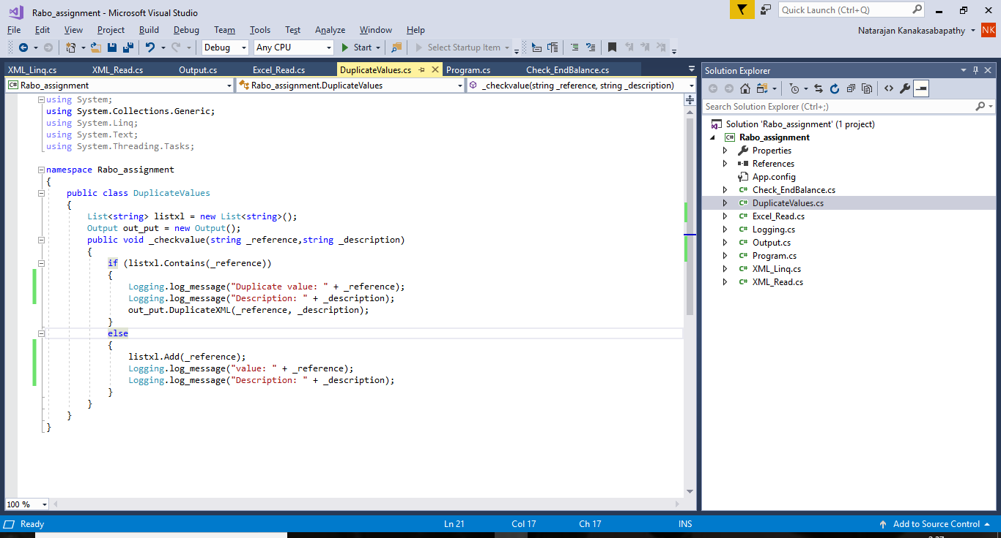

1. **Output.cs**

This class performs writing the output to xml file.

* Duplicate reference and description.
* End balance validation.

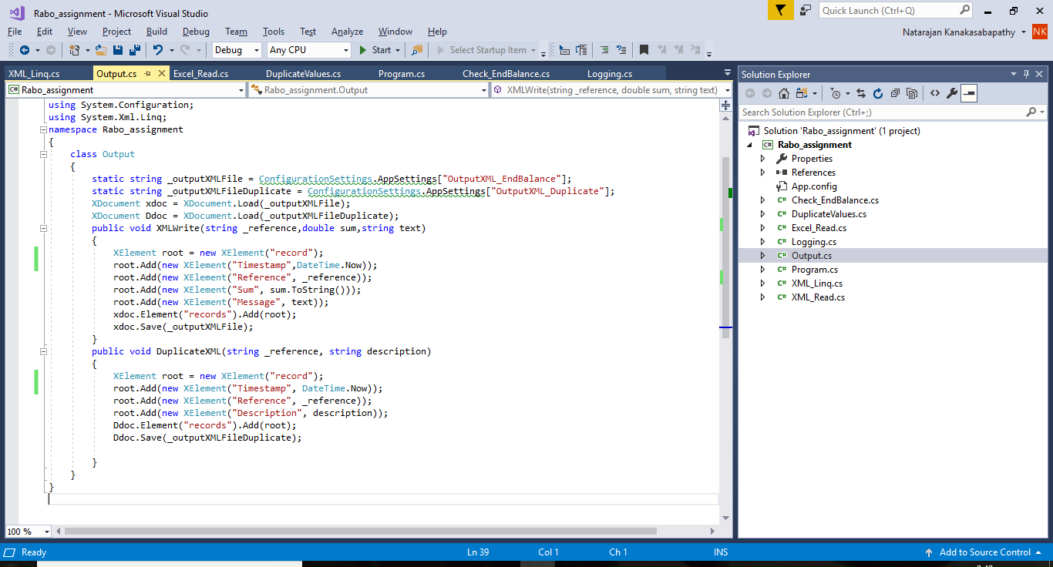

**6.Logging.cs**

Logging of events is performed using this class.

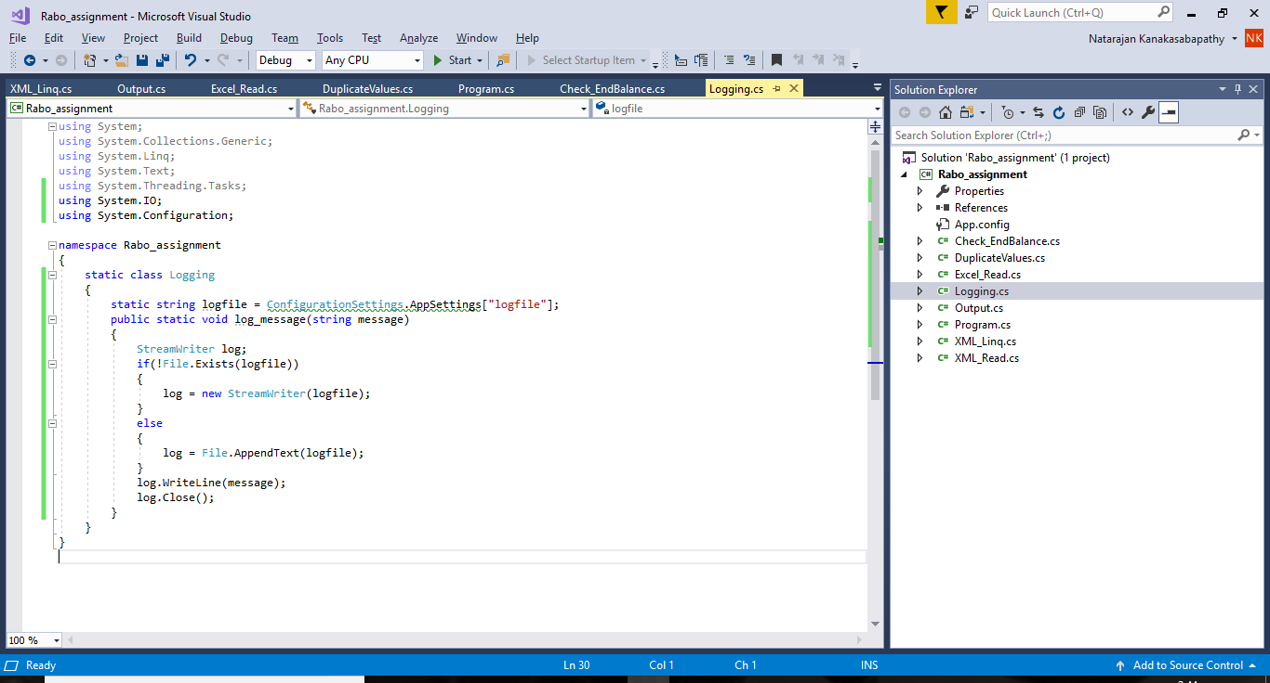

**7.Sample output files:**

**Duplicate reference values and End balance field:**

